COURSE: CLOUD AND NETWORK SECURITY _C1-2024
STUDENT NAME: LENNIE NTHIGA
STUDENT NO: cs-cns07-24170
OCTOMBER 24,2024

WEEK 5 ASSIGNMENT 2
Assignment 1: Introduction to Web Applications

Contents
Introduction 3
Web Applications vs. Websites vs Native operating System Applications 3
Websites 3
Web applications 3
Native Operating System Applications 3
Web Application Distribution 4
Security Risks of Web Applications 4
Attacking web applications 4
Web Application Layout 5
Web Application Infrastructure 5
Web Application Components 6
Web Application Architecture 6
Microservices 7
Serverless 7
Architecture Security 7
Front End vs. Back End 7
Front End 7
Back end 8
Securing Front /Back End 8
FRONT END COMPONENTS 9
HTML 9
URL Encoding/percent-encoding 9
Usage 9
CASCADING STYLE SHEET (CSS) 11
FRAMEWORKS 11
JavaScript 12
Frameworks 13
FRONT END VULNERABILITIES 13
Sensitive Data Exposure 13
Prevention 13
Html injection 15
Cross-Site Scripting (XSS) 16
Cross Site Request Forgery (CSRF) 18
Prevention 18
BACK END SEVERS 19
Software 19
Hardware 19
Web servers 20
APACHE 20
NGINX 20
IIS (Internet Information Services) 20
Static Vs. Dynamic Web Servers 20
Databases 21
APIs 23
SOAP 23
Rest 24
CONCLUSION 27

Introduction
Web applications are interactive applications run in browses usually for the purpose of clients to access information, goods and services from vendor. Basically, any person who requires a web application can own one built by a web developer making it possible for anyone to be able to access different markets and new ones. Web applications are made with a front-end component/client side that is what the clients /users see and interact with and back-end/server side that is the functionality of the web application ,integrations, databases configurations and settings are made and accessed by the developer side.
We would get to know the functions of in the websites and web applications and their workings and attacks

Web Applications vs. Websites vs Native operating System Applications

Websites
- It’s a collection of interlinked web pages connected through a domain name
- Usually have a static visual -meaning the information displayed is same content to all users who access it
- Usually used to display information for any users to access without personalization e.g. blogs, news company website
- Less complex

Web applications
- It’s a software accessed through a web browser
- Usually developed with a consideration of the end users in mind thus has a sense of personalization in it e.g. in the search pattern ,geographic location basis, user device and requests
- Are dynamically visual thus personalized thus keep changing in view and displayed information
- More complex
- Most requires authentication
- Version unity thus the applications can be modified and updated before being accessed thus not limit to the resources of user device

Native Operating System Applications
- They are applications that are installed in the users’ devices that is their computers, laptop or phones that have an operating system. The applications can be incompatible to the operating system one is running or the versions can stop being supported in some operating systems
- Some applications can have a limitation of the user interaction when they have an android version and computer version operating system
- They are faster with higher performance
- Can work offline without internet access
- Have a better user experience
- Native applications can be : progressive application that is applications that use a browser and URL to access
And hybrid applications that can be accessed using the web and also native wise

Web Application Distribution
They can be built by the user to be either open-source or closed source
Open-source applications are applications that the user made and made the source code for the application be modified by anyone e.g. word press, OpenCart
Closed source applications are made by a user for the private uprose of an organization/group of users thus protection mechanism for the aspirations source code and whole functionality can be interfered with by external personnel unless authorized. E.g. shopify ,Alibaba

Security Risks of Web Applications
Web applications have a vast amount of security risks since it can be viewed from anywhere in the world
A successful web application attack can lead to significant losses and massive business interruptions. Since web applications are run on servers that may host other sensitive information and are often also linked to databases
That’s why web pen testing is critical into recognizing the vulnerabilities in the web application for them to be fixed and patched

Attacking web applications
An attack is an action taken against something thus in reference to web applications there many various actions taken against an organization
Vulnerabilities is a weakness that can be exploited
Common Examples: https://owasp.org/www-community/attacks/ with the vulnerabilities that come about he web applications are mostly broadly discussed in the site for owasp https://owasp.org/www-community/vulnerabilities/
- SQL injections- consists of insertion or “injection” of a SQL query via the input data from the client to the application thus a successful SQL injection exploit can read sensitive data from the database, modify database data
- Forced browsing- Forced browsing is an attack where the aim is to enumerate and access resources that are not referenced by the application, but are still accessible. Done by using brute forcing techniques to search for unlinked contents in the domain directory
- Session hijacking attack -The Session Hijacking attack consists of the exploitation of the web session control mechanism, which is normally managed for a session token.
The attacks have grown and changed in manner and scope with time so as the methods of detecting ,tracking and prevention of an attack have also grown side to side.
- Attackers take considerations of deep understanding of technology and solid motivation to exploit vulnerabilities
- Reconnaissance -gathering of information on the web application, system ,interlinked web applications, their IPS/IDS, the versions of the servers and such
- Finding ways of ways of not being detected when scanning the system and gaining control from technologies such as firewalls and intrusion detection system
- They tend to study the system deeply on how they can maintain access by avoiding virus/malwares scanners and detectors
- Clearing evidence by clearing logs added scripts ,programs after finally exhausting their finding and wishes https://www.researchgate.net/publication/363143829_The_Basic_Concept_of_Cyber_Crime

Web Application Layout
Web applications have different layout depending on then organizations use their differences can be categorized as

Web Application Infrastructure
Describes the components that the web app requires to function that might be the database, servers .
They have web app infrastructure have different models such as:
- Client-server →where by the web application the front end is executed in the client side that is the browser while the interpretations and the functions are in the hosted server. Thus, when one clicks a function or uses the user interface the request would be sent to the server where it would be interpreted and carry the task and respond to the browser with the results
- One severs → the entire web application is hosted in the server and the same server can be hosting other several web applications and distributing it to any client who wasn’t to access it.
It is a risky model since if the server is down then no web application would be functioning. The risk of attack is higher if other web apps are not well secured
- Many servers -one databases →This model separates the database (database server) and the server this allows the web applications' hosting server to access the database server to store and retrieve data when required only by first accessing the server where the server requires the database its where it would and retrieve the data. It can be one server-one database or many servers one database
Advantage of this is segmentation
- Many servers -many databases → here every server has their own private separate database and only shared content is shared among the databases on the web applications .
Its best reduces redundancy time when one server is offline however would require a load balancer that would facilitate the issuance of resources

Web Application Components

They are the parts that enable the functioning of the web applications:
- Client – the end user e.g. browser
- Server -the location where the web application is hosted and the components used for it to work e.g. database, webserver
- Services (microservices)- might include 3rd parties that could enable the increase of the applications effeminacy e.g. integrations ,cloud services
- Functions (serverless)- the processes that take place for a task to be completed

Web Application Architecture
It’s the structural architecture that guides the design and the development of the web application.
They are dived into 3 layers
- Presentation layer -consists on the components the user would interact with that is the user interface at the web browser
- Application layer – ensures that all the clients requests are processed correctly before responding
- Data layer -this layer determines where and how the data is going to be stored Woking closely with the application layer

Microservices
Are independent components in a web application that programmed to carry out specific tasks on the application e.g. payments ratings reviews
The communication between these microservices is stateless, which means that the request and response are independent because the data is stored separately. This microservices can be programmed in different languages and work with each other

Serverless
serverless architecture is a way to build and run applications and services without having to manage infrastructure thus the management of the infraorders is managed by the vendors under a certain price. Mostly offered by vendors such as AWS,AZURE,GCP

Architecture Security
In many cases, an individual web application's vulnerability may not necessarily be caused by a programming error but by a design error in its architecture.
Example the user might have secured all the functionality but hasn’t limited the data accessed by a user from the shared databases thus making it accessible even to any user or the allocation of the admin rights isn’t limited to user’s that can cause problems .
Architecture security one should be considering the 3 principals’ confidentiality, integrity and availability. Thus, during development and implementation one should design the web application that would sever those principals

Front End vs. Back End
Full stack development is the combination of both frontend web development and backend development

Front End
These are the components that the user interacts with (UI user interface) which is the client-side usually programmed in different languages e.g. HTML ,JAVASCRIPT ,CSS , SAAS ,ruby and such JANGO
The front-end part should be designed in a manner of considering the ease of the user to use it must be as simple and relatable to the end user to use otherwise if complex training is conducted
The front end is designed with colours ,screen size, fonts and writings that don’t affect the end user

Back end
Back end contains the processes and functions that run the tasks the web application is designed for.
Components of back end :
- Web servers-the hardware that the web application is hosted on and the operating system that runs it when running the web application that can be APACHE, NGINX
- Databases -is the organized collection of structured information and data done by database systems that in different categories e.g. relational databases e.g. MySQL, centralized e.g. fireproof, cloud databases e.g. aws, distributed and many more
- Development framework – is a set of tools libraries and conventions that enable the creation of a web application e.g. Django for python, Laravel for PHP or NodeJS for JavaScript
One can also store the components pf the web applications separately by by utilizing services such as docker where by database can be stored in a container while the other part of the web application is stored in another container. Thus, protecting it from vulnerabilities that can affect the entire web application

Securing Front /Back End
Using good coding structuring as the first discipline if not well structured the code can be manipulated and become vulnerable
The font end user interface (buttons, inputs, checkbox) is a major entry point of communication with the web applications components thus exploitable to cross site script and injections thus this user interfaces can be filtered properly limited and have checking functionality before being processed
Having encryption mechanisms for the data stored and in transit
Monitoring and logging of the data can be used in detections and analysis
Error handling functions to handle data leaks or database errors
Managing sessions securely by having session expiry and token-based authentications for APIs
Implementing robust authentications mechanisms which can also protect the users’ credentials /can also have 2 /3 factor authenticators
Proper http header configurations e.g. enabling CSP in http header to prevent XSS attacks
Using modern updated frameworks come with built in security practices and standards that are beneficial during coding

FRONT END COMPONENTS

HTML
Hypertext massage language is a programming language for web dev commonly used .The web browser interprets these elements of HTML and displays them to the user
Each element is having an opening tag and closing tag

URL Encoding/percent-encoding
For a browser to properly display a page's contents, it has to know the charset in use. Browsers URL use ASCII encoding that is any character set to the URL has to be encoded to the ASCII encoding characters and replaces the unsafe ASCII characters with a % symbol followed by two hexadecimal digits.
E.g. ‘ us encoded to %27 and so

Usage
each element is represented as a DOM document Object Model
DOM is a cross-platform and language-independent interface that treats an HTML or XML document as a tree structure wherein each node is an object representing a part of the document.
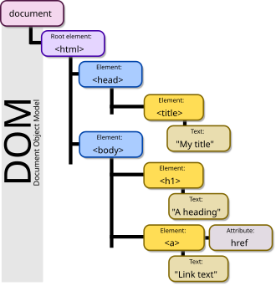
Nodes can have event handlers within them and once an event is tiggered the event handler gets executed
In HTML DOM (Document Object Model), every element is a node
- A document is a document node.
- All HTML elements are element nodes.
- All HTML attributes are attribute nodes.
- Text inserted into HTML elements are text nodes.
- Comments are comment nodes.
We can locate the HTML elements by their ids their tag name or by their class name can be useful when we want to utilize front-end vulnerabilities (like XSS) to manipulate existing elements .
With the growing technology html has upgraded to HTML5 as the recent version.most of the recent websites are made using HTML4 but in both most of the elements are present
Some of the things improves in HTML5 are:
- Introduced several new elements that provide better semantic meaning to web content. E.g. <article> ,<figure>
- Supporting multimedia without the need for Flash or other plugins that is <audio> and <video>
- Promoting design responsiveness and consistency across browsers
- Reducing the overlap between HTML, CSS, and JavaScript
Question:
What is the HTML tag used to show an image? <img>
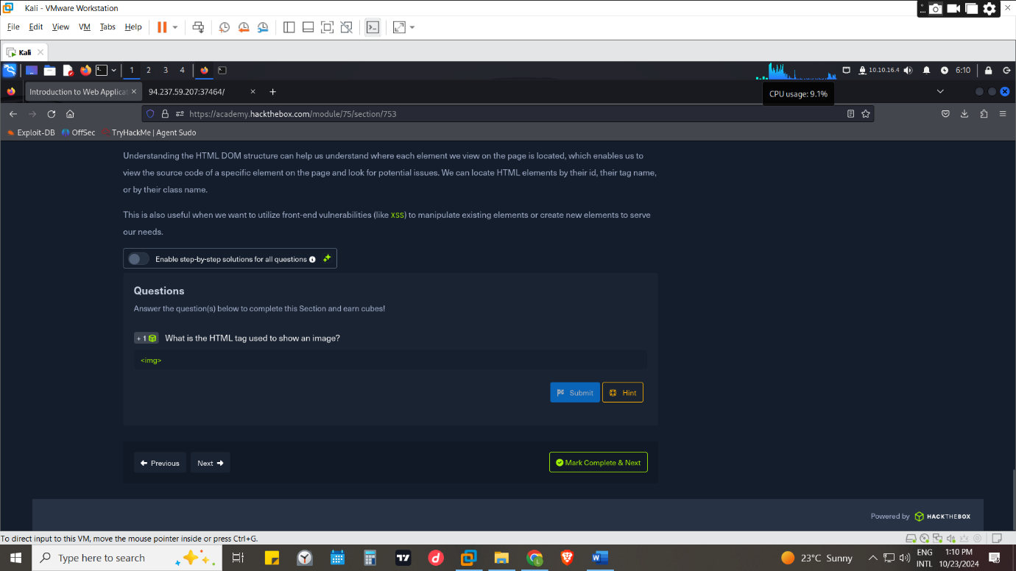

CASCADING STYLE SHEET (CSS)
Is a style sheet language used for specifying the presentation and styling of a document written in a markup language by including layouts ,colours and fonts
CSS can be applied internally in together with the html code by including the tag <style > between here one can style a number of HTML elements<style>
Can be inline CSS where by the CSS style us specified to a HTML element
e.g. <body style="background-color:black;">
External CSS is whereby the styling of the HTML elements are writing in a different file but relate to the elements that are in the HTML file to be styled .Then IN the HTML file a link is added to link the CSS file with the HTML file .The CSS file would have a format file ending with .css
The link linking them would be <link rel="stylesheet" type="text/css" href="style.css" />
The href defining the location of the file ending with the file name

FRAMEWORKS
A framework is a platform that helps coders design an application by providing pre-written code within templates. Frameworks come with library code that works together to simplify the syntax, grammar that makes it simple to develop with different designs and creative styles
They are available for most languages for HTML, CSS, JAVASCRIPT and so on
E.g. bootstrap has HTM, CSS and JAVASCRIPIT uses
SaaS mostly CSS
Foundation
Bulma
Question :
+ 1 What is the CSS "property: value" used to make an HTML element's text aligned to the left? text-align: left;
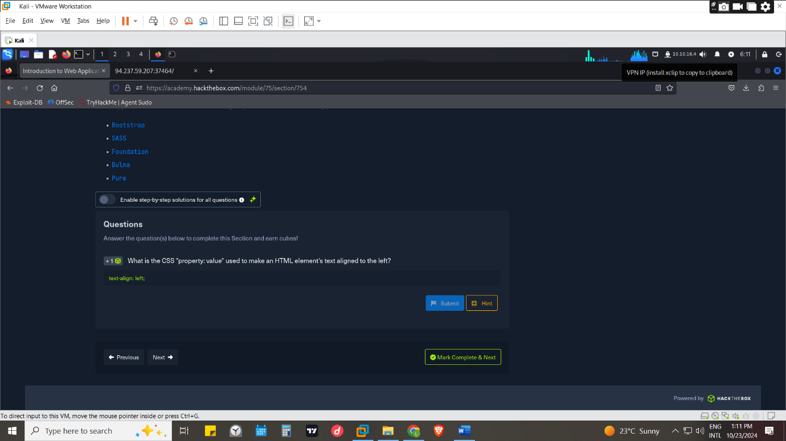

JavaScript
JavaScript is a light-weight object-oriented programming language that is used by several websites for scripting the webpages, mobile applications, presentations, server applications and games. It helps the users to build modern web applications to interact directly without reloading the page every time
It’s used to control any functionality that the front-end web page requires.
https://developer.mozilla.org/en-US/docs/Web/JavaScript/Guide
it’s included to HTML file together with CSS by using <script> <script> elements
<script type="text/javascript">
.JavaScript code.
</script>
Uses of JavaScript:
- Used to automate complex processes and perform HTTP requests to interact with the back-end components
- Used alongside CSS, as previously mentioned, to drive advanced animations that would not be possible with CSS alone
- Web browsers are equipped with JavaScript engines that can execute JavaScript code on the client-side without relying on the back-end webserver to update the page
- Updating the web page view in real-time, dynamically updating content in real-time

Frameworks
It may be inefficient to use pure JavaScript to develop an entire web application from scratch
These platforms introduce libraries that make it very simple to re-create advanced functionalities, like user login and user registration, and they introduce new technologies based on existing ones e.g. Angular, jQuery, Vue, React

FRONT END VULNERABILITIES

Sensitive Data Exposure
Front end components are the side the client interacts with from the web browser. Even though most attackers focus on the back end the front-end side one can view the source code and by using proxies such as burp suite or curl tool one can view the requests and responses .
From this source code one can identify a useful information that can help in exploiting a vulnerability in a web application they can be test pages, directories, debugging parameters , hidden functionality this information’s can give further information of access
Some of the attacks that front end attackers use is :
- Clickjacking - Uses transparent overlays on a trusted page to trick users into clicking on something different than they perceive.
- HTTPs downgrades -done by Stripping away HTTPS encryption facilitates thus spying on user traffic.
- Dependency risks – since most web apps relay on 3rd party dependencies for the functionality pf the web apps they can be outdated or deprecated thus increasing a chance of having a vulnerability within it that can be used to access the web app
- Xss cross site scripting- involves injecting malicious client-side code

Prevention
Having good code writing that does not include unnecessary code that is bare/expandable o unused.
Classify data types within the source code and apply controls on what can or cannot be exposed on the client-side
Having review of client-side code to ensure that no unnecessary comments or hidden links are left behind
Disable caching for response that contain sensitive data.
Inclusions of automated technologies for checking the code before final release and regular checkup
Ensure up-to-date and strong standard algorithms, protocols, and keys are in place
In reference of https://owasp.org/www-project-top-ten/2017/A3_2017-Sensitive_Data_Exposure
Question
Check the above login form for exposed passwords. Submit the password as the answer. HiddenInPlainSight
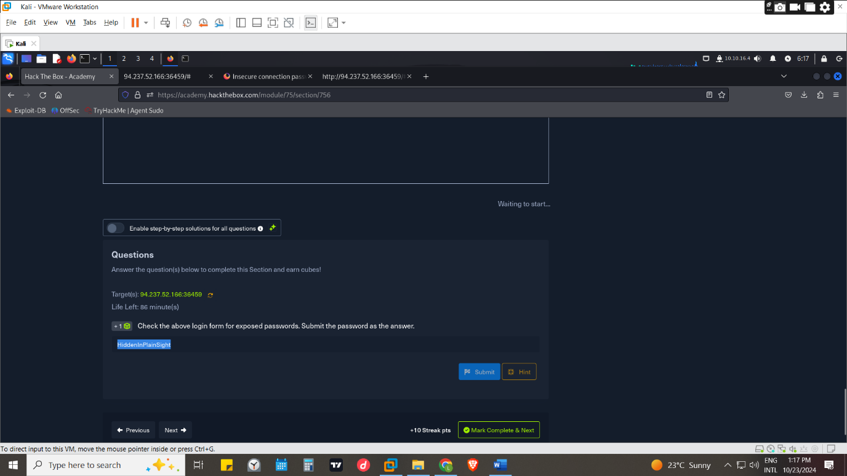
Found in the source code at view source code in the browser
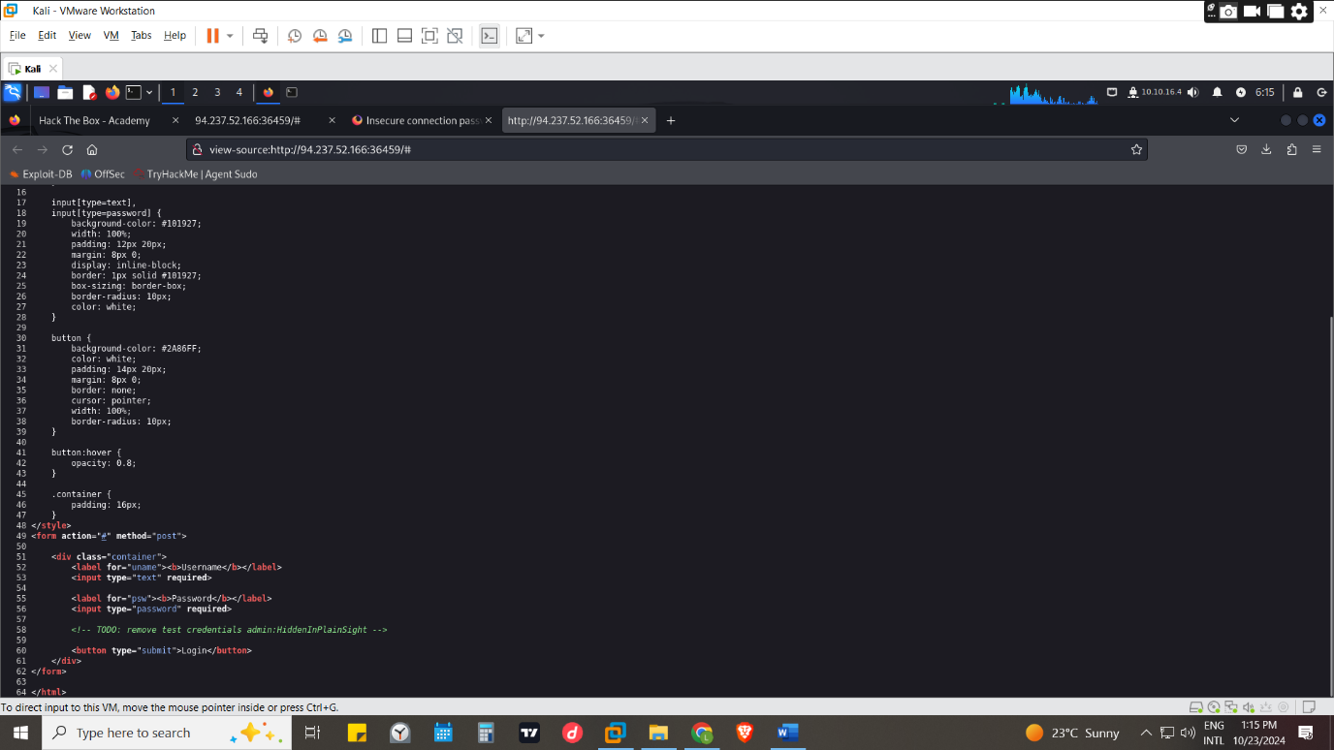

Html injection
HTML injection occurs when unfiltered user input is displayed on the page
This can either be through retrieving previously submitted code, like retrieving a user comment from the back-end database, or by directly displaying unfiltered user input through JavaScript on the front end.
When an attacker has control of the web app input point they can send a malicious HTML code that can be placed as part of the web application pages and sent to a victim when the victim opens it and the code runs the code could be a credentials logging page when the victim inputs it and sends it the attacker would receive it and use it as they pleasehttps://owasp.org/www-project-web-security-testing-guide/latest/4-Web_Application_Security_Testing/11-Client-side_Testing/03-Testing_for_HTML_Injection
Question
What text would be displayed on the page if we use the following payload as our input: <a href="http://www.hackthebox.com">Click Me</a> Your name is Click Me
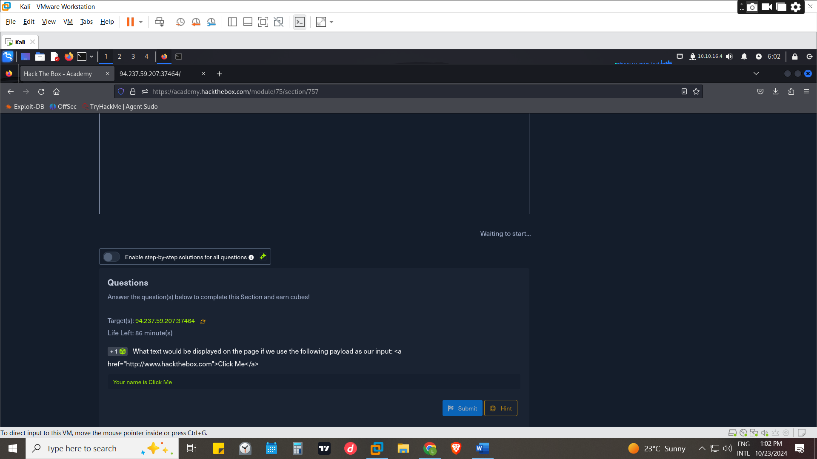
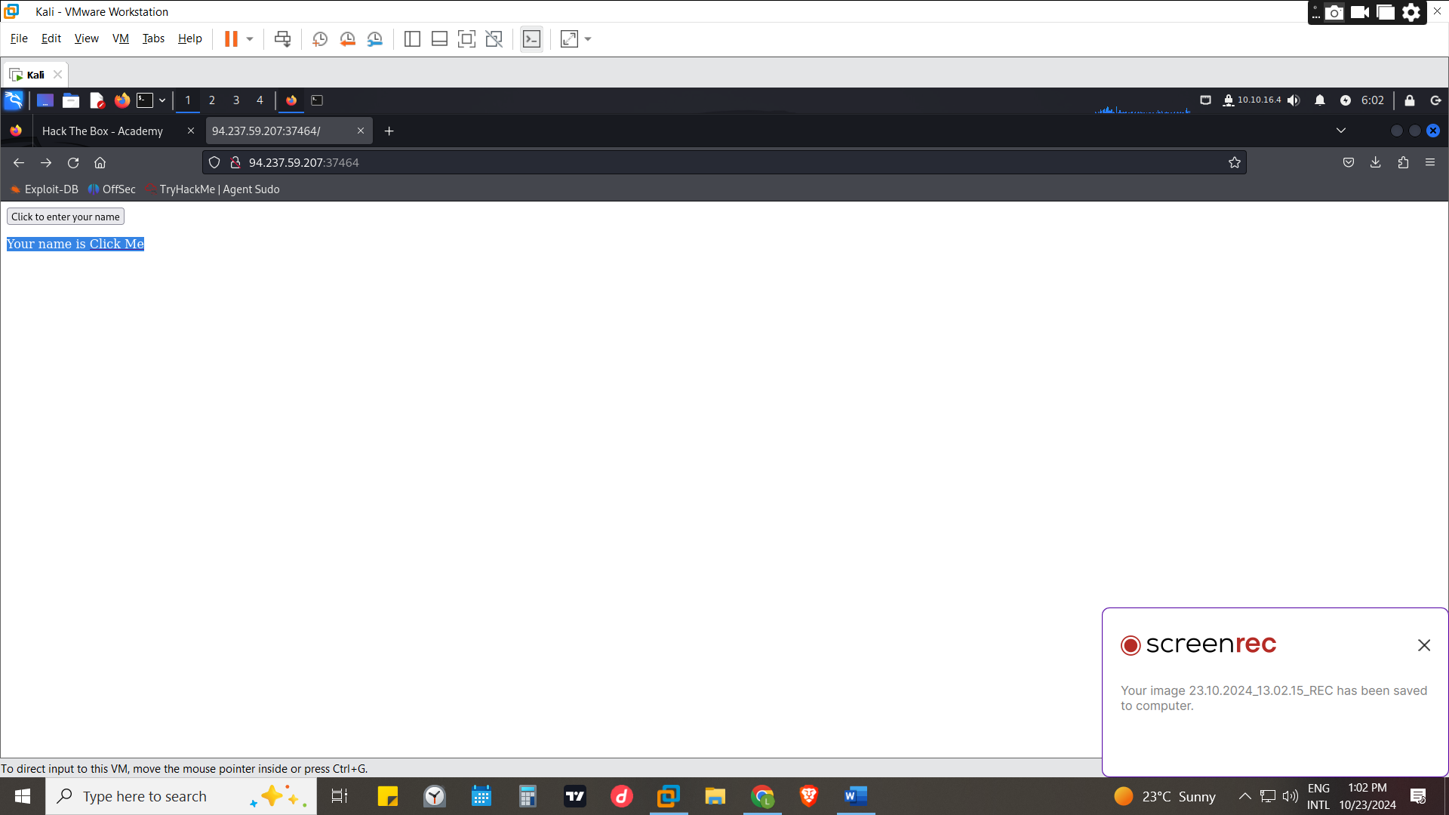

Cross-Site Scripting (XSS)
It’s an attack which may utilize HTML injection in which malicious scripts are injected into trusted websites. works by manipulating a vulnerable web site so that it returns malicious JavaScript to users. Occur when an attacker uses a web application to send malicious code, generally in the form of a browser side script, to a different end user. When the malicious code executes inside a victim's browser, the attacker can fully compromise their interaction with the application.
They commonly include transmitting private data, like cookies or other session information, to the attacker, redirecting the victim to web content controlled by the attacker
There 3 types of XSS attacks:
- Reflected XSS -occurs when a user is tricked into clicking on a malicious link, submitting a specially crafted form, or even just browsing to a malicious site, the injected code travels to the vulnerable web site, which reflects the attack back to the user’s browser. The browser then executes the code because it came from a “trusted” server
- Blind XSS - occurs when the attacker’s payload saved on the server and reflected back to the victim from the backend application.
- Stored XSS - are those where the injected script is permanently stored on the target servers, such as in a database, in a message forum, visitor log, comment field the victim then retrieves the malicious script from the server when it requests the stored information
- DOM bases XSS - Occurs when user input is directly shown in the browser and is written to an HTML DOM object
It intends to steal cookies, spread malware, manipulate content, capture input or execute malicious scripts
Questions
Try to use XSS to get the cookie value in the above page XSSisFun
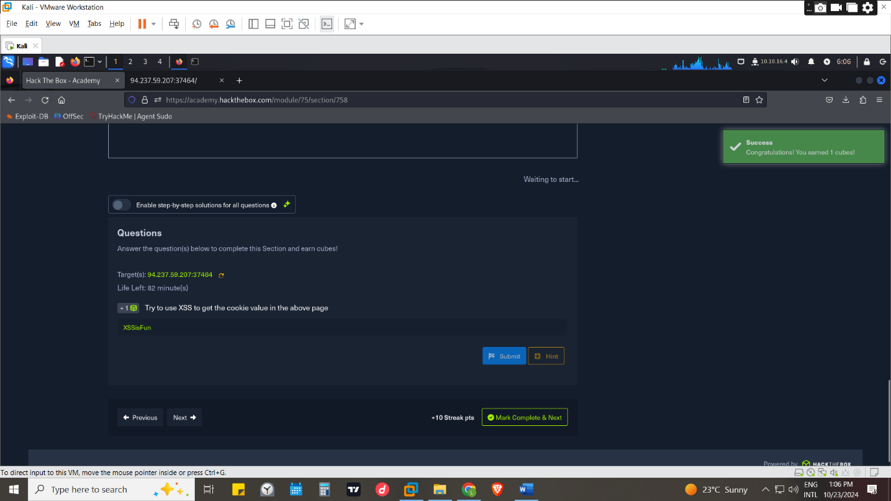
Finding the cookie in the inspect storage tab
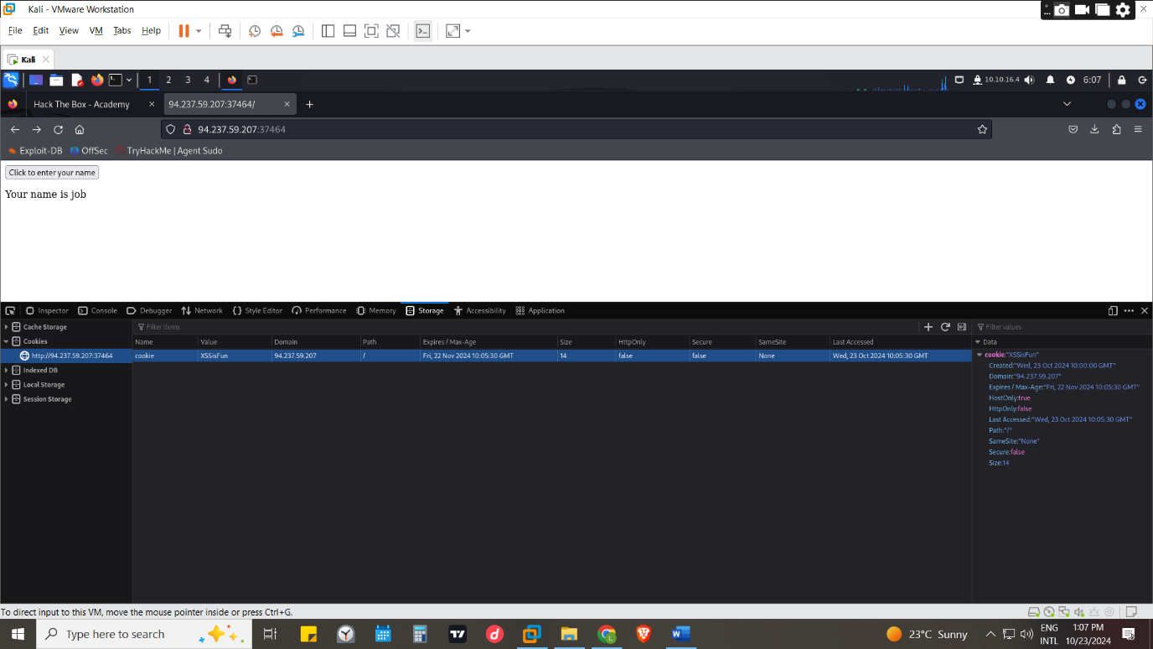

Cross Site Request Forgery (CSRF)
It’s a vulnerability that is caused by unfiltered user input the attack targets Web applications failing to differentiate between valid requests and forged requests controlled by attacker.
CSRF attacks may utilize XSS vulnerabilities to perform certain queries, and API calls on a web application that the victim is currently authenticated to by tricking the victim into clicking a URL that contains a maliciously crafted, unauthorized request for a particular Web application thus executing actions of the attacker’s choosing. Can be to perform actions as the authenticated user
Social engineering is useful here to know how to approach the victim through what way without arousing suspicion and by increasing chances of being executed in reference of https://www.blackduck.com/glossary/what-is-csrf.html
Can also be leveraged to attack admins and gain access to their accounts which have sensitive functions

Prevention
- Using unique CSRF token which would differentiate a legitimate request from a fake request they are inserted within hidden parameters of HTML forms
- Filtering and sanitize user input on the front end before it reaches the back end. This is by sanitization(means removing special characters and nonstandard characters from user inputs before displaying to storing it) and before displaying it to the output
- Validation -Ensuring that submitted user input matches the expected format
- implement a web application firewall (WAF), which should help to prevent injection attempts automatically. However, can be bypassed

BACK END SEVERS
It’s the hardware and operating system on the back end that hosts all of the applications necessary to run the web application.
It’s the back-end server that would be running and processing most of the tasks
It contains 2 components the software and the hardware

Software
It refers to the program or software application responsible for handling HTTP (Hypertext Transfer Protocol) requests from clients.
Its job is to store and process the web content and display it to the user when requested

Hardware
It’s the physical hardware that runs the software ,it includes the ram, storage space that is HDD or SSD or magnetic disks ,GPU
These resources are shared among the web applications to provide the power and performance on those web applications in responsiveness
QUESTIONS
What operating system is 'WAMP' used with? Windows
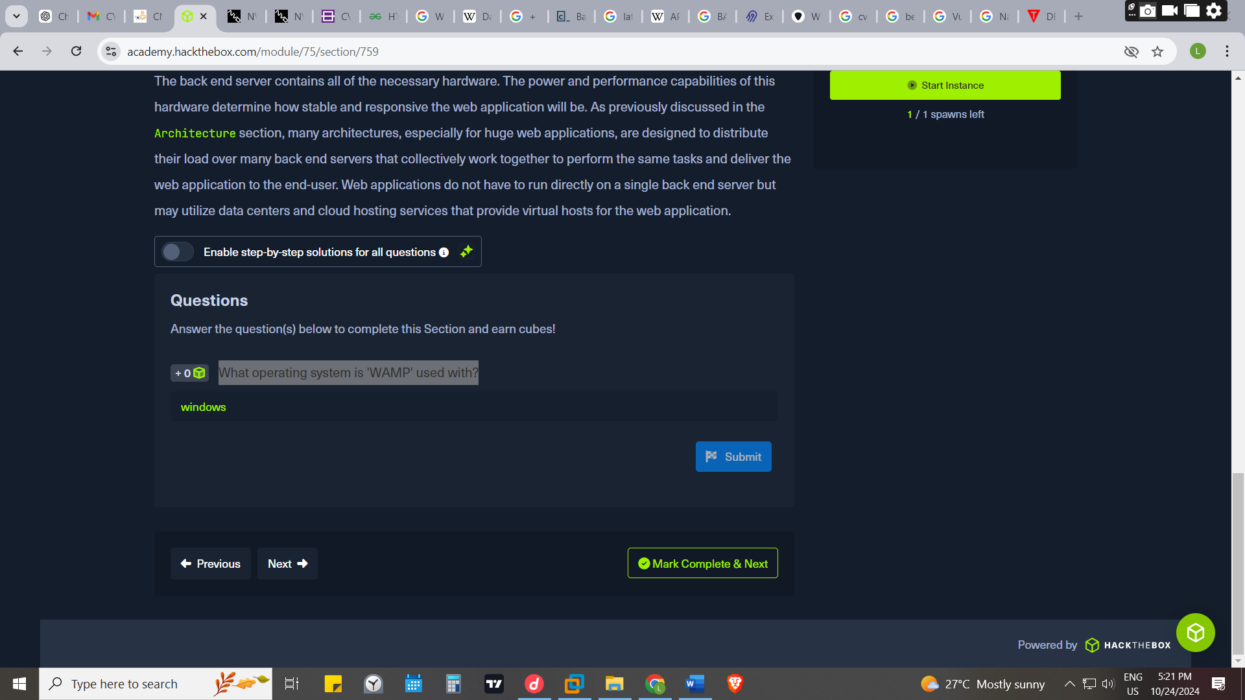

Web servers
is an application that runs on the back-end server facilitate the delivery of content and services to users worldwide.
Its responding to user requests, hosting websites, and overseeing data transmission.
Web server accepts HTTP requests from the client-side, and responds with different HTTP responses and codes
We can even develop our own basic web server using languages such as Python, JavaScript, and PHP. However, for each language, there's a popular web application that is optimized for handling large amounts of web traffic, which saves us time in creating our own web server

APACHE
It’s the most common web server host most of the websites. Usually used with PHP for web application development, but it also supports other languages. Its open-source project but regularly patched against vulnerabilities

NGINX
It is the second most common web server on the internet, focuses on serving many concurrent web requests with relatively low memory and CPU load by utilizing an async architecture to do so. It’s also free and opensource

IIS (Internet Information Services)
Its developed and maintained by Microsoft and mainly runs on Microsoft Windows Servers but can also be used to host web applications while offering services like FTP
IIS is very well optimized for Active Directory integration and includes features like Windows Auth for authenticating users using Active Directory, allowing them to automatically sign in to web applications.
Many of the Organizations use Windows Server on their back end or rely heavily on Active Directory within their organization

Static Vs. Dynamic Web Servers
When choosing the type of a server to use one should look at the types of content, complexity, infectiveness and scalability

Static server
- The content generated remains unchanged unless a developer updates it manually because the content is hard coded in the page.
- Delivery is pre-rendered pages that are typically cached and delivered via a content delivery network (CDN)
- Static sites remain the same for all who access them regardless of the browser

Dynamic web servers
- Dynamic references to the content that are controlled externally with the CMS or external database
- They have dynamic pages which are generated in real-time at the time of the request by the server.
- The pages can use client-side JavaScript to make pages dynamic in real-time thus change with customization

Questions
If a web server returns an HTTP code 201, what does it stand for? Created
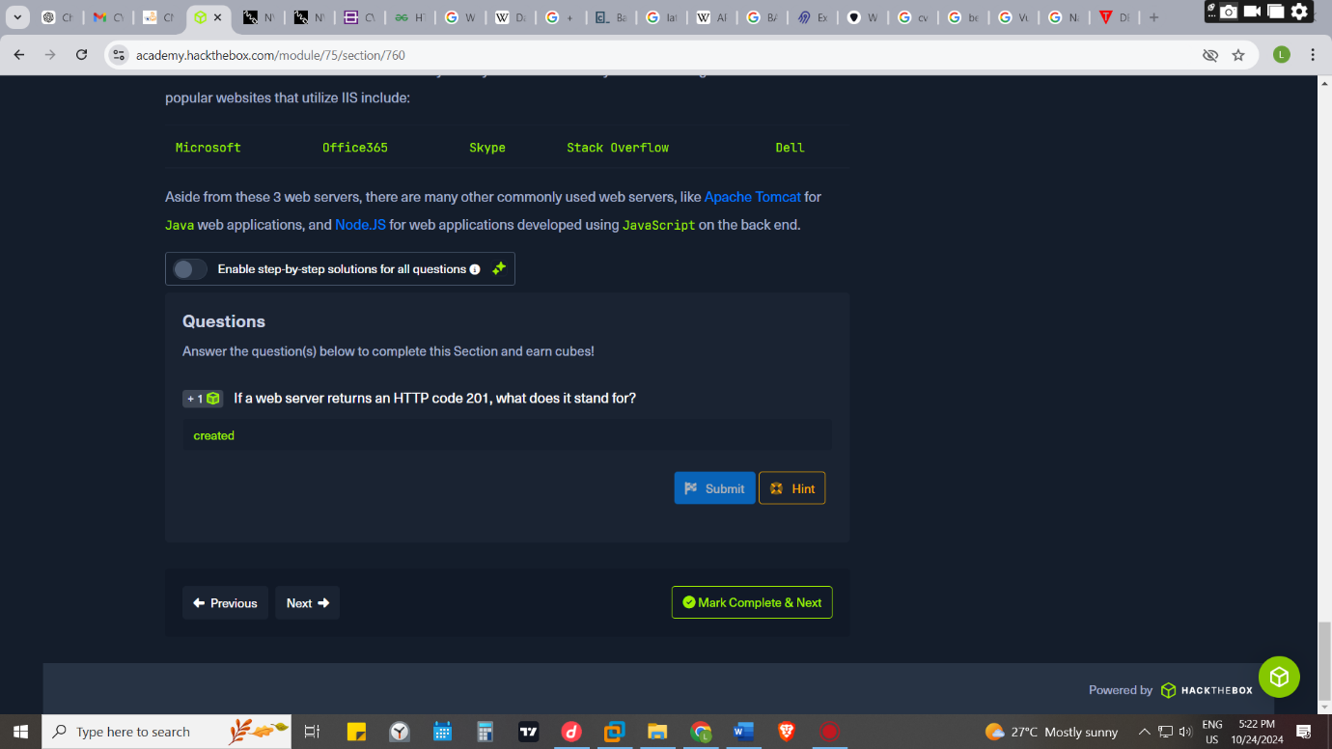

Databases
A database is an organized collection of data, so that it can be easily accessed and managed.
They can be used to store company credentials, documents , media or records and such.
In choosing a data base one should consider:
- Usability- how user-friendly the system will be for the members of staff
- Security- sensitive data and any personal information you hold must be stored securely to adhere to regulations and to protect it from loss or theft.
- Support -one should think about the support service the software company offers for its solution when there rises a problem at the company
- Integration- this is the ability of integrating the database with other services
- Scalability- the ability to grow in size/capacity without a decrease in its performance
Common types of databases:
- Relational (SQL)
These databases store their data in tables, rows, and columns. Each table can have unique keys, which can link tables together and create relationships between tables.eg MySQL ,Microsoft SQL server ,oracle database
It’s the simplest database to understand and easy to retrieve data
- Non-relational (NoSQL)
It’s a database stores data using various storage models, depending on the type of data stored does not use tables, rows, columns, primary keys, relationships, or schemas. Thus, they are very scalable and flexible. e.g. MongoDB, Apache Cassandra ,Redis
- Object-oriented Databases
The data is represented and stored as objects which are similar to the objects used in the object-oriented programming language. E.g. Wakanda gemstone, object DB
By the holding data in objects, they can easily represent intricate data models without requiring multiple tables and joins. This makes them particularly well-suited for complex, interrelated data applications such as multimedia content ,engineering designs
There many more types can be refenced at https://airbyte.com/data-engineering-resources/types-of-database
Questions
What type of database is Google's Firebase Database? NoSQL
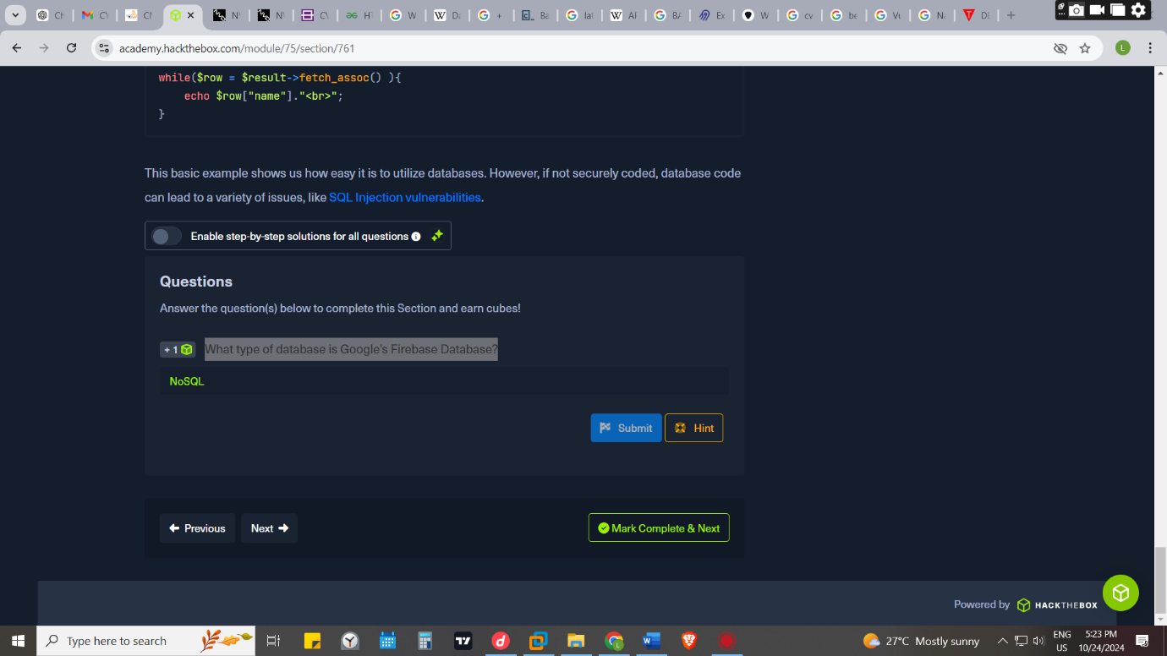

APIs
Application programming interface – is a software intermediary that allows the front-end component to interact with the back end and ask for certain tasks to be carried out, they utilize APIs to ask the back-end component for a specific task with specific input .They can be used to extract data and share data across organizations
One can build an API for an organization to give other organization for them to use the data in their system egg payment APIs used in ecommerce applications or a weather API that would be integrated with weather sensors thus behaving depending on the weather reports
Moreso APIS are used to retrieve data but not to manipulate them that is adding or deleting the data from the APIS source

SOAP
The SOAP (Simple Objects Access) standard shares data through XML, where the request is made in XML through an HTTP request, and the response is also returned in XML
SOAP gives you much more guidance on the structure of the request and response, as well as the message content and how it will be encoded it can be aligned with other protocols
it provides four distinct dimensions to the API protocol:
- Envelope: Defining the structure of the message.
- Encoding: Rules for expressing the type of data.
- Responses: How each SOAP API response is structured.
- Requests: How each SOAP API request is structured.
Soap is best used for the exchange of structured information in distributed environmentsIt has built-in error handling features, which makes it easy to understand what happened when a request fails. However, its usually slower and more complicatedIt lets applications that are running on different operating systems and in different programming languages communicate with each other.it can be used in bank transfers, booking flights , city managements and shipping companies

Rest
Its (Representational State Transfer) standard shares data through the URL path usually returns the output in JSON format
Unlike Query Parameters, REST APIs usually focus on pages that expect one type of input passed directly through the URL path, without specifying its name or type. This is why REST APIs usually break web application functionality into smaller APIs and utilize these smaller API requests to allow the web application to perform more advanced actions, making the web application more modular and scalable.REST uses various HTTP methods to perform different actions on the web application that is the GET, POST, PULL and DELETE
Questions
Use GET request '/index.php?id=0' to search for the name of the user with id number 1?
Superadmin
Was found by running curl -X GET "http://94.237.55.180:39323/index.php?id=1"
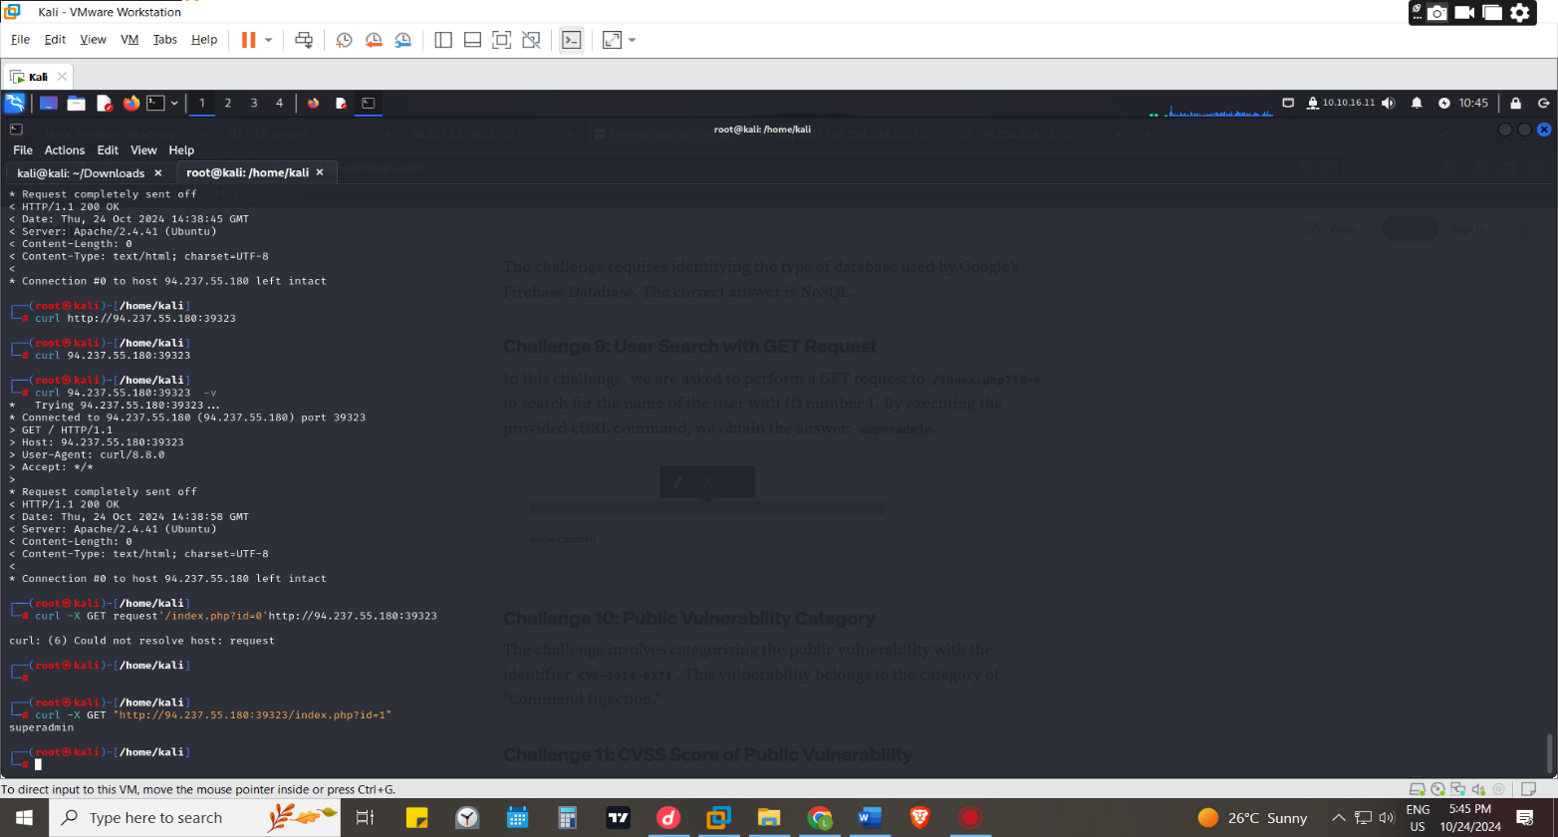
Common web vulnerabilities
The discussion on the vulnerabilities have been discussed at the page with attacking web application
Questions
To which of the above categories does public vulnerability 'CVE-2014-6271' belongs to? Command injection
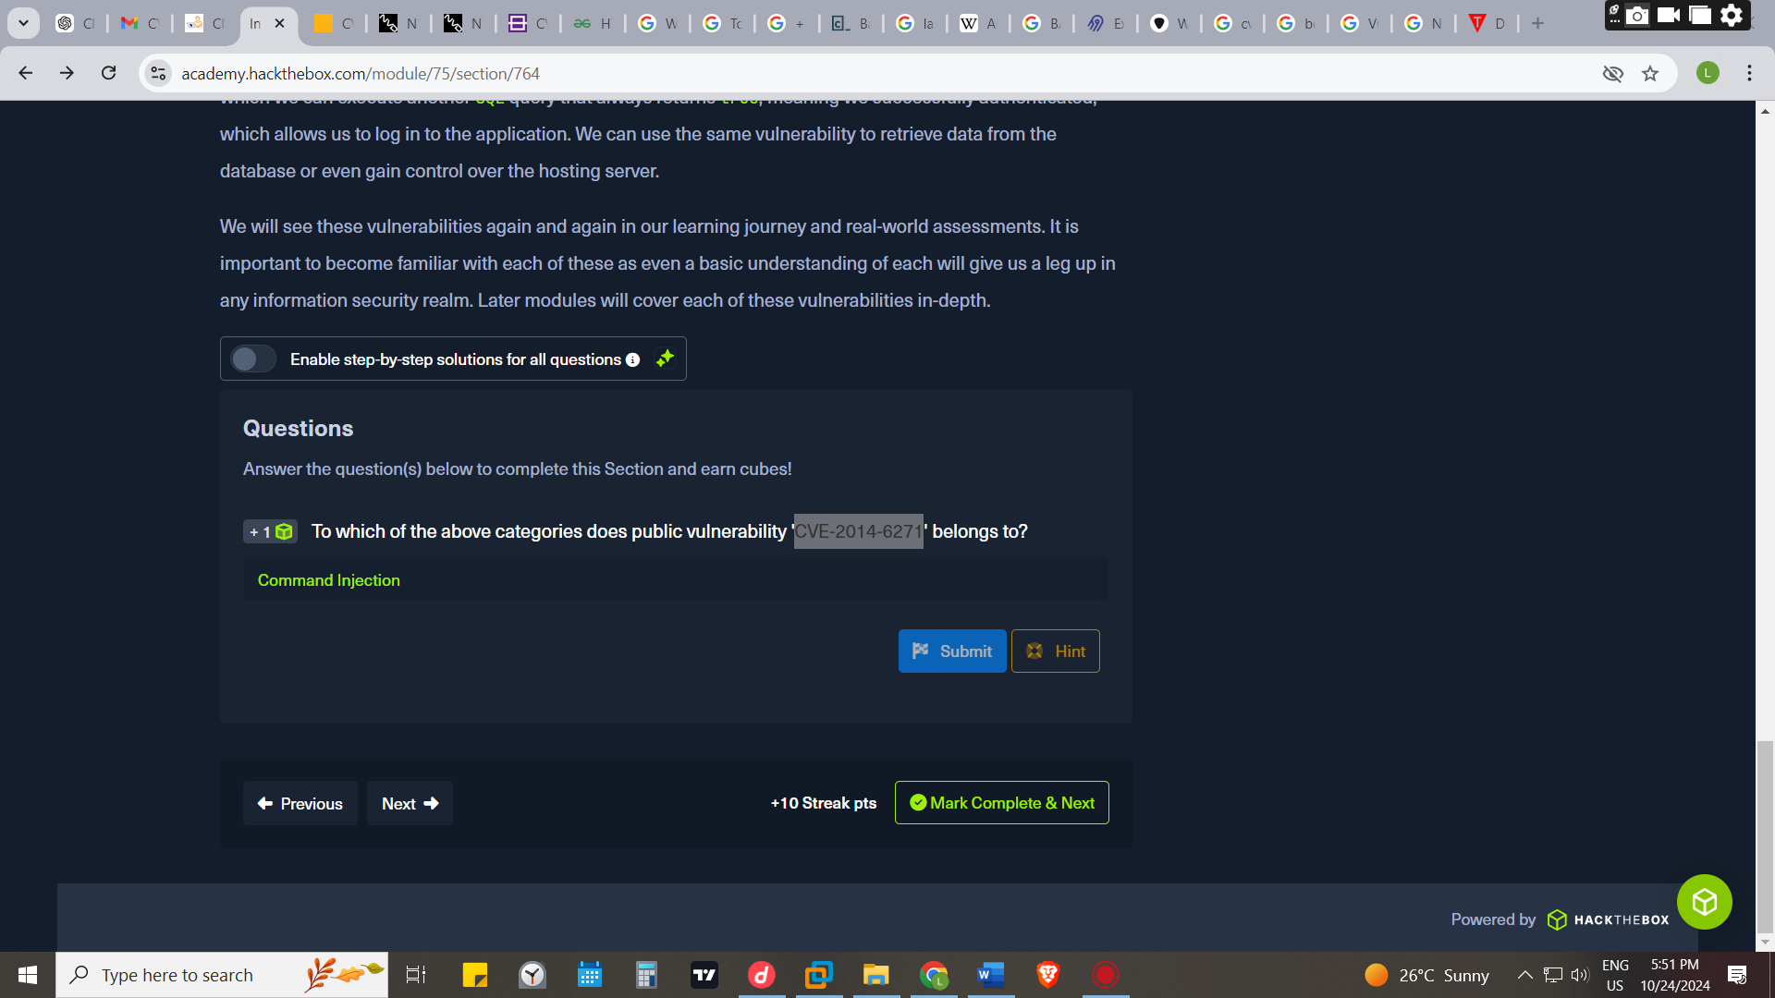
Public Vulnerabilities
Public CVE
CVE is Common Vulnerabilities and Exposures is a list of publicly disclosed computer security flaws
Mitre https://cve.mitre.org/ ,rapid 7 https://www.rapid7.com/db/ ,vulnerability lab https://www.vulnerability-lab.com/ and Exploit DB https://www.exploit-db.com/ are websites with databases that contain robust amounts of CVEs and exploits that have been explained together with the dates of publishing and their effects
Common Vulnerability Scoring System (CVSS)
It’s an open-source industry standard for assessing the severity of security vulnerabilities. This scoring system is often used as a standard measurement for organizations and governments that need to produce accurate and consistent severity scores for their systems' vulnerabilities helps with the prioritization of resources and the response to a given threat.
The National Vulnerability Database (NVD) https://nvd.nist.gov/ provides CVSS scores for almost all known, publicly disclosed vulnerabilities. The NVD only provides Base scores based upon a given vulnerability's inherent characteristics it does not factor in Temporal and Environmental metrics because the former can change over time due to external events.
Environmental is based on the potential impact of the vulnerability on a given organization
CVSS scores are based on a formula that uses several metrics: Base, Temporal, and Environmental.
QUESTIONS
What is the CVSS score of the public vulnerability CVE-2017-0144? 9.3
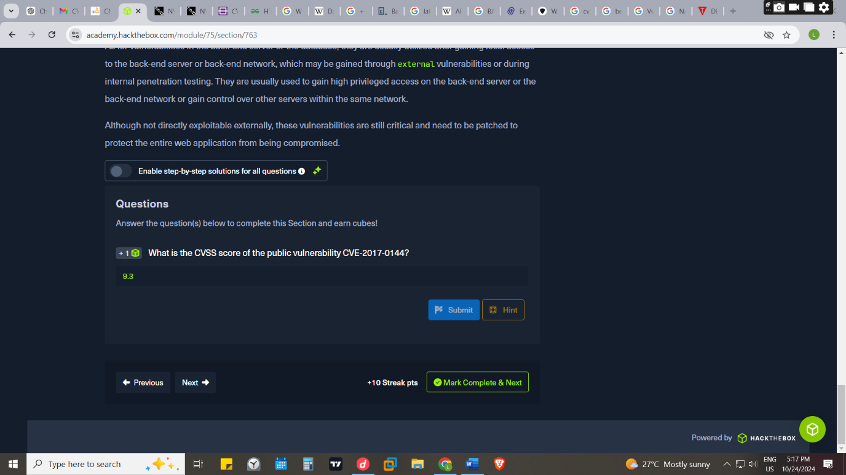
Found by googling at https://nvd.nist.gov/vuln/detail/cve-2017-0144
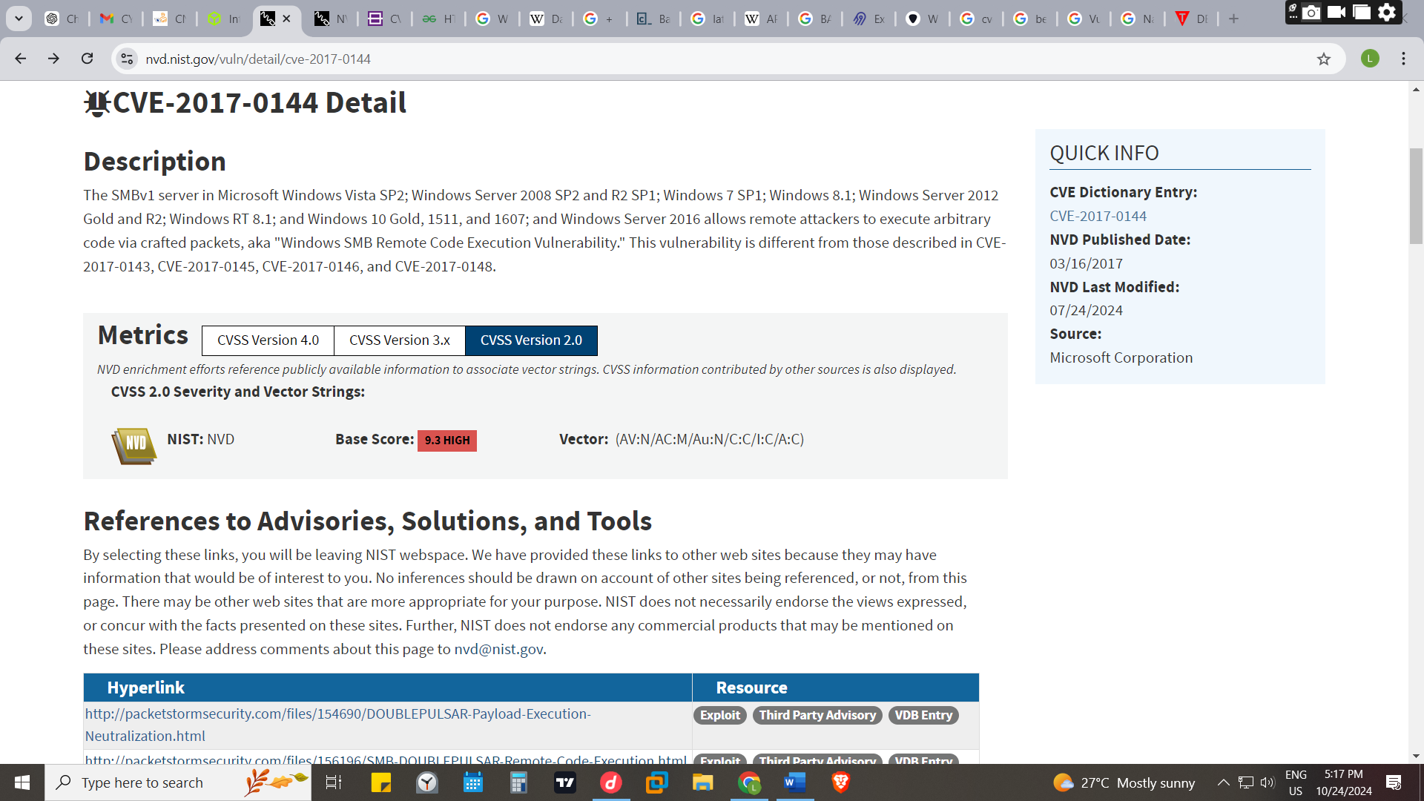

CONCLUSION
In the creation of a web application its suitable to use development framework because they enable the develop to use quality code and come with in build security features thus assisting in securing of the web applications. However much a web application is secured it’s preferably ok to carryout pen testing for deeper penetrations testing of the applications to detect data licks and missed errors for patching
Its important to note that for the safety and usability of the clients/end user’s interaction is by encouraging them on updating of the organizations software for better performance or have an inbuilt feature that would be triggering automated updates for them

Completion
https://academy.hackthebox.com/achievement/376159/75
